## DAA LAB

## LAB 6: Implement Minimum Spanning Tree Algorithms - Prims Algorithms and Kruskal Algorithm.

# **PRIMS ALGORITHM**

**PROGRAM:**

**#include<stdio.h>**

**#include<conio.h>**

**int a,b,u,v,n,i,j,ne=1;**

**int visited[10]={0},min,mincost=0,cost[10][10];**

**void main()**

**{**

**printf("\n Enter the number of nodes:");**

**scanf("%d",&n);**

**printf("\n Enter the adjacency matrix:\n");**

**for (i=1;i<=n;i++)**

**for (j=1;j<=n;j++) {**

**scanf("%d",&cost[i][j]);**

**if(cost[i][j]==0)**

**cost[i][j]=999;**

**}**

**visited[1]=1;**

**printf("\n");**

**while(ne<n) {**

**for (i=1,min=999;i<=n;i++)**

**for (j=1;j<=n;j++)**

**if(cost[i][j]<min)**

**if(visited[i]!=0) {**

**min=cost[i][j];**

**a=u=i;**

**b=v=j;**

**}**

**if(visited[u]==0 || visited[v]==0) {**

**printf("\n Edge %d:(%d %d) cost:%d",ne++,a,b,min);**

**mincost+=min;**

**visited[b]=1;**

**}**

**cost[a][b]=cost[b][a]=999;**

**}**

**printf("\n Minimun cost=%d",mincost);**

**}**

**OUTPUT:**

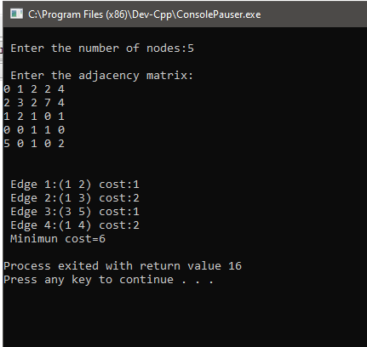

## **KRUSKALS ALGORITHM**

**PROGRAM:**

**#include<stdio.h>**

**#include<conio.h>**

**#include<stdlib.h>**

**int i,j,k,a,b,u,v,n,ne=1;**

**int min,mincost=0,cost[9][9],parent[9];**

**int find(int);**

**int uni(int,int);**

**void main()**

**{**

**printf("\nEnter the no. of vertices:");**

**scanf("%d",&n);**

**printf("\nEnter the cost adjacency matrix:\n");**

**for(i=1;i<=n;i++)**

**{**

**for(j=1;j<=n;j++)**

**{**

**scanf("%d",&cost[i][j]);**

**if(cost[i][j]==0)**

**cost[i][j]=999;**

**}**

**}**

**printf("The edges of Minimum Cost Spanning Tree are\n");**

**while(ne < n)**

**{**

**for(i=1,min=999;i<=n;i++)**

**{**

**for(j=1;j <= n;j++)**

**{**

**if(cost[i][j] < min)**

**{**

**min=cost[i][j];**

**a=u=i;**

**b=v=j;**

**}**

**}**

**}**

**u=find(u);**

**v=find(v);**

**if(uni(u,v))**

**{**

**printf("%d edge (%d,%d) =%d\n",ne++,a,b,min);**

**mincost +=min;**

**}**

**cost[a][b]=cost[b][a]=999;**

**}**

**printf("\n\tMinimum cost = %d\n",mincost);**

**}**

**int find(int i)**

**{**

**while(parent[i])**

**i=parent[i];**

**return i;**

**}**

**int uni(int i,int j)**

**{**

**if(i!=j)**

**{**

**parent[j]=i;**

**return 1;**

**}**

**return 0;**

**}**

**OUTPUT:**

